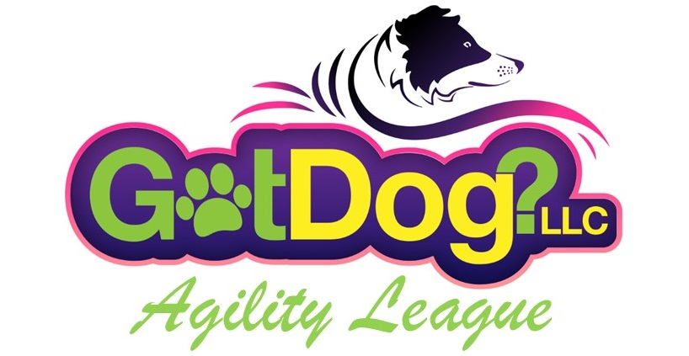

Looking for a new, fun and different way to play agility?  Want to play against handlers across the nation or internationally?  **Want to win money?**

We are bringing a new twist to the agility world.  Facilities, teams, and individuals will all play for a League pool of money each league session! No ribbons, no trophies….just pure monetary winnings! For those wanting more challenge, we added a Distance Game Event! **Please note, entering the Individual or Distance Game Event does NOT enter you in the Team Event. Team is a separate Event.**

The GotDog Agility League will consist of 6 rounds of agility per session. Three courses will be uploaded on the first of the month, and you will have that month to complete all three rounds. The next 3 courses will be uploaded on the first of the next month, and you will have that month to complete the last three rounds. There will be two ways a handler could be eligible for money. Signing up a dog for the Individual Event or the Distance Game (one or the other, not both) and signing up for the Team Event. A Facility could also earn money by nominating their facility for League Play.

**Individual Event:** Each handler submitting an Individual application form will pay $75 per dog, which will go into the Individual Event winnings pot.  After the 6 rounds have been scored, the Champion will be named for the highest scoring dog in each competitive group. The competitive groups will be determined by the dog’s speed index. The speed index will be calculated based on the dog’s yards per second (YPS) on a particular sequence on the first three standard agility courses.

We will pay out **Money** to the Champions. Depending on the number of entries, payouts could go down to fourth place. If a handler also signs up their dog for the Team Event, their Individual scores automatically go toward their dog’s team overall score.

**Distance Game Event:** Handers should already be attempting bonuses in other venues. Each handler submitting a Distance Game application form will pay $75 per dog, which will go into the Distance Game Event winnings pot.  After all 6 rounds have been scored, the Champion will be named for the highest scoring dog in the Distance Game. We will pay out **Money** to the Champions. Depending on the number of entries, payouts could go down through fourth place. If entries warrant a speed index split for separate groups, we may choose to do so. But as of now, all Distance Game Event dogs will compete together.

There will be a Distance Area indicated on the course map, where you can earn additional scoring Game Points. While the handler is in the distance area, two (2) Game points will be awarded for each successfully completed obstacle on the first attempt. The handler may leave the distance area at any time and return to the distance area to continue earning game points. The scoring will be the same as the Individual Event (time + faults deducted from a 250 base score). Game points will be added after the dog’s score is determined.

If the dog is in Team, The Distance Game scores will go toward your Team and Facility scores, but Game points will not be included in Facility or Team scores.

**Team Event:** Each handler submitting a Team application form will pay $30 per dog, which will go into the Team winnings pot.  Each team will consist of three dogs. To create balanced teams, the dog names will be randomly drawn by GotDog and our goal is for each team to consist of one of each speed index group. The dog’s scores participating on a team will be added together and the team with the highest overall score will be named the Team Champions. We will pay out **Money** to the Champions. Depending on the number of entries, payouts could go down through fourth place.

If you *only* enter a dog in the Team event, your dog will still run each round to earn the scores for the Team event. You will not be eligible for the Individual or Distance Game payouts, only the Team payouts, if your team places.

**Facility Nominations:** Training facilities or private agility fields can nominate themselves as a GAL’s location. When entries close, a facility must have a minimum of 6 representatives. The facility owner will pay $125 when they fill out and submit the Facility application form and their facility will be listed as a choice for individuals to indicate they are running for that facility/field when they enter the league. A handler does not have to run ‘at’ the facility/field but could still indicate their scores are to go toward a particular facility**.  Once all runs are completed, scores from the top six representatives of a facility will be summed up and averaged for their Facility overall score.**  The Facility with the highest average score will be named the Champion. Depending on the number of Facilities nominated, payouts could go down to 4 places. The winner of the Facility/field competition will also receive a banner saying they are the winners of the ‘GotDog Agility League’ (including Year and session #) and also their logo on the banner.

**General Rules**

You may use your height cards to indicate your wither height from any of the major agility organizations.  We will not require height cards but if we question the dog’s height we may ask for it.  You will be able to jump your dog at the height you jump them in any of the major agility organizations using their jump height rules.

Scoring will be time plus faults.  Your score will start with 250 points, minus your faults and your time. If you enter the Distance Game Event, your Distance Game points earned will be added after the run’s total scoring points. Your overall score will be the accumulation of all 6 runs.

Round 1 - 5 course scores will be posted on the website after each run has been judged. Round 6 will not be posted until all of Round 6 runs have been run and judged. We will announce when course 6 scores are posted and winners declared.

The style of courses will vary. For example, the course may be a Regular or Standard type, or a Jumpers course, or one with more contact performances or more weave performances than normal. All courses will be of the Elite or Excellent/Open level.

You may not warm-up or practice on any equipment on the league course prior to starting your first attempt. A practice jump or hoop outside of the ring is allowed.

The league course MUST be videoed on the VERY first attempt only. Please video it from the area marked on the map for your camera**, keep in mind we need to see all the equipment, including the contact zone of the down side of the contacts!** If a piece of equipment hides a farther out jump, for example, please move either left or right so all equipment is visible. And be sure that all contact areas are visible, which means you might have to repaint your lines if they are faded. You must upload the video to YouTube and submit your video link via a form on our website. One person could video all league players and submit each run on one form.  No payment at submittal because you have already entered that league session.

EVERY run must be submitted even if you have faults. If you do not submit a run, your score will be zero. If you train a contact by purposely putting the dog back on the contact, 50 faults will be added to your score.

PLEASE NOTE: If during the time of our judging the video runs, we feel you are not submitting your first attempt, or the course is set short, we reserve the right to disqualify you, your team and the facility you run under.

Equipment to be used:  A Frame and Dogwalk (any surface that is accepted in any of the major agility organizations), Weave poles (both 12 and 6), jumps (winged or non-winged), tunnels (15’ or 20’), hoops (which can be substituted with a jump), but not the other way around and barrels (possibly).

Updated 3/9/24